Rice & Shine🇮🇹


DID YOU KNOW?
“Sun dried tomatoes have been shown to have a high concentration of lycopene, a powerful antioxidant. Research shows this could help protect you from the sun. This protects you from becoming a sun dried tomato yourself. “

Ingredients
175g of risotto
750ml of boiled water
1 vegetable stock paste
1 brown onion
3 cloves of garlic
200g of asparagus tips
200g of tenderstem broccoli
5 sundried tomatoes
100g baby plum tomatoes
1 tbsp of butter
20g of hard Italian style cheese
2 tbsp of balsamic vinegar

Nutrition – Total / Per Serving
Calories: 961kcal / 480.5kcal
Carbohydrates: 173g / 86.5g
Protein: 26g / 13g
Fat: 17g / 8.5g
Fibre: 14g / 7g
Sugar: 11g / 5.5g






Good for:

Star Rating:


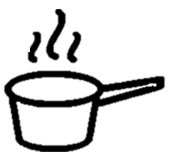

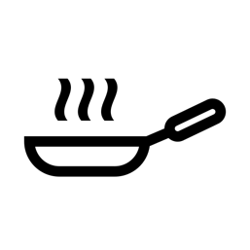


Method
Step 1 - Preparation
Boil the kettle for the water.
Preheat the oven to 220°C.
Dice the onion and garlic.
Trim the bottom of the asparagus tips and then slice in half.
Halve the tenderstem broccoli and tomatoes.
Place the asparagus, broccoli, and tomatoes on a baking tray.
Add your boiled water to a sauce pan together with the stock.


Step 2 – Frying Time
Heat some oil in a frying pan.
Once hot, add the onion and fry until softened (~3-4 mins)
Add the garlic and sundried tomatoes. (~1 min)
Add the risotto to the frying pan and mix. (~1-2 min)



s
Step 3 – Rice, Rice Baby
Slowly add the stock from the saucepan into the frying pan. Roughly add 100ml per time allowing the risotto to soak up the stock before adding more. Keep on medium heat and stir occasionally. (~20 mins)

Whilst you wait, add salt and pepper to the baking tray and place in the oven. (~10 mins)
Step 4 – Bring it Together
Once the risotto is al dente, remove the pan from the heat.
Mix in butter and 2/3rd of the cheese.
Serve the finished risotto and place the roasted broccoli, asparagus, and tomatoes on top.
Drizzle the balsamic vinegar and the remaining cheese on top.

Enjoy!

